**Lesson Notes**

1. What is the main purpose of an Operating System?

The main purpose is for simple and efficient application programs, consistent user experience, and allowing multiple applications running at the same time.

* + Operating System handles the Computer Hardware
  + Operating System handles resource allocation
  + Operating System provides a standard User Interface (Windows)
  + Operating System provides a standard way to store and browse data files and folders (File Explorer)
  + Operating System Provides Ownership Control (User Accounts)
  + Operating System Schedules the CPU (Task Sharing)

1. What is the difference between Operating System Software and Use Application Software?

The difference Operating System Software and Use Application Software is hardware independence, user interface, and resource allocation.

* + Same applications can run on different computer hardware
  + Operating System must be configured according to hardware components present in the computer
  + Applications focus on what is contained and displayed within a window
  + Operating System controls opening / closing / resizing windows and responding to mouse and keyboard actions
  + Operating System provides standard ways to print, save and open files, access the internet, etc.
  + Applications just ask for what they need (e.g. Memory, Disk Space)
  + Operating System checks for availability and access permission
  + Operating System coordinates resource allocation between applications

1. What is the difference between Operating System Software and Computer Hardware?

The difference between Operating System Software and Computer Hardware is that hardware is touchable, OS is intangible, and softwares controls all PC operations.

1. What are the main parts of an Operating System?

The main parts of OS are graphical user interface, system calls, device drivers, and I/O manager.

1. What are some popular operating systems?

Some other popular operating systems are Windows, iOS, and Andriod.

**Reference Diagram**

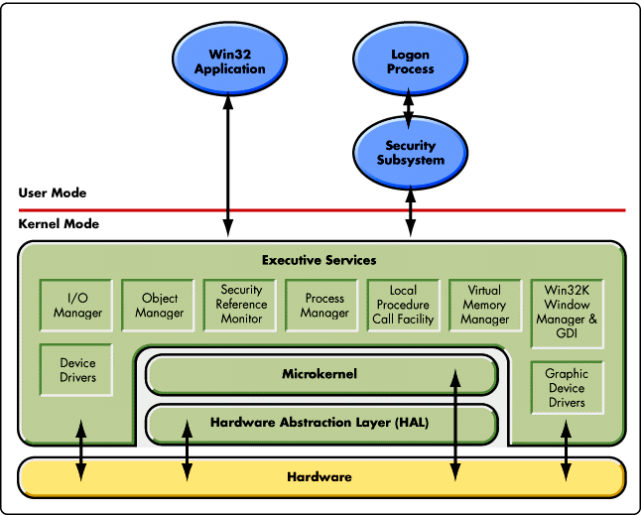

**Student Questions**

1. What is a device driver?
   1. Provide a brief summary

Device driver helps the device run properly in conjunction within the software.

* 1. List some devices that require a device driver.

Some devices that require a device driver are GPU, sound card, and a printer.

* 1. Provide a label on the reference diagram for the location of a device driver for your graphics card.

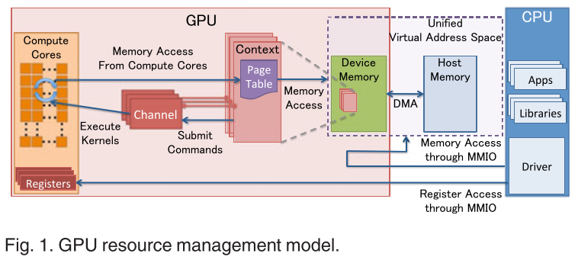

* 1. Provide a label on the reference diagram for the location of a device driver for a locally attached printer.

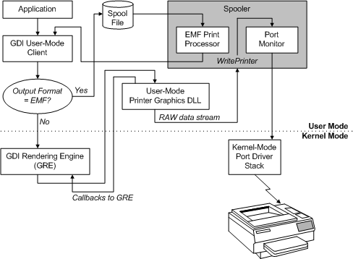

1. What is a DLL?
   1. Provide a brief summary

A DLL is a program running on Windows OS, most of the functions of the program are given by DLL.

* 1. Explain how DLLs are related to user application programs

DLL are related to user application programs to help functions running on the program.

* 1. Provide a label on the reference diagram for the location of a DLL

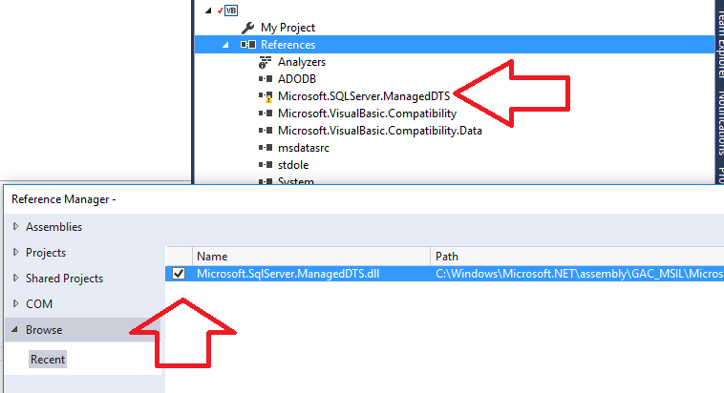

1. What is a windows manager?
   1. Provide a brief summary

A windows manager coordinates all windows on screen.

* 1. Explain how a windows manager is related to user application programs

Windows manager is related to user application programs because every program that is running is controlled by Windows Manager.

* 1. Provide a label on the reference diagram for the location of a DLL

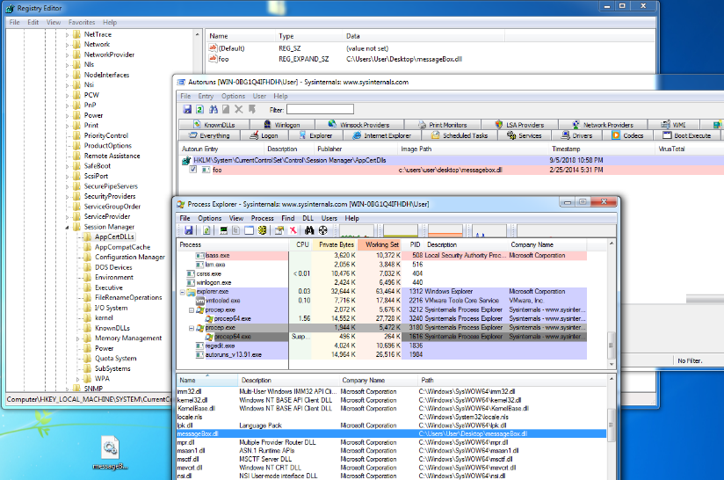

1. What is the windows task manager?
   1. Provide a brief summary

A windows task manager is to show a list of background and foreground operations that are running. This allows you to force end tasks.

* 1. List and explain four (4) types of system information provided by the task manager

4 types of system information which is provided by the task manager is programs which are users, details, app history, and performance.

* 1. Provide a label on the reference diagram for the operating system components related to each type of information.

